## PROGRAM DEFINITION

|  |
| --- |
|  |
| * A program to generate a report for a list of overtime charges that already or will be processed into an invoice |

## RELATED TABLES

|  |  |
| --- | --- |
|  | **Access** |
| * - | * - |

## ROLES

|  |  |
| --- | --- |
|  | **Test** |
| * User that has access to program |  |

## INITIAL PROCESS

|  |  |
| --- | --- |
|  | **Test** |
| * Set VAR_COMPANY_ID = Login User’s Company ID * Set VAR_USER_ID = Login User’s ID * Set VAR_LANGUAGE_ID = Login User’s Language ID * Execute this stored procedure, save the results to VAR_YEAR_RANGE   EXEC RSP_GS_GET_PERIOD_YEAR_RANGE  VAR_COMPANY_ID  , ''  , ''   * Set VAR_LOOKUP_BUILDING_LIST_GET_RECORD = Value from lookup GSL02200 * Set VAR_LOOKUP_DEPARTMENT_LIST_GET_RECORD = Value from lookup GSL00700 * Set VAR_LOOKUP_TENANT_LIST_GET_RECORD = Value from lookup PML00600 * Set VAR_LOOKUP_SERVICE_LIST_GET_RECORD = Value from lookup PML00400 |  |

## MAIN FORM

### USER INTERFACE

#### INITIAL VERSION

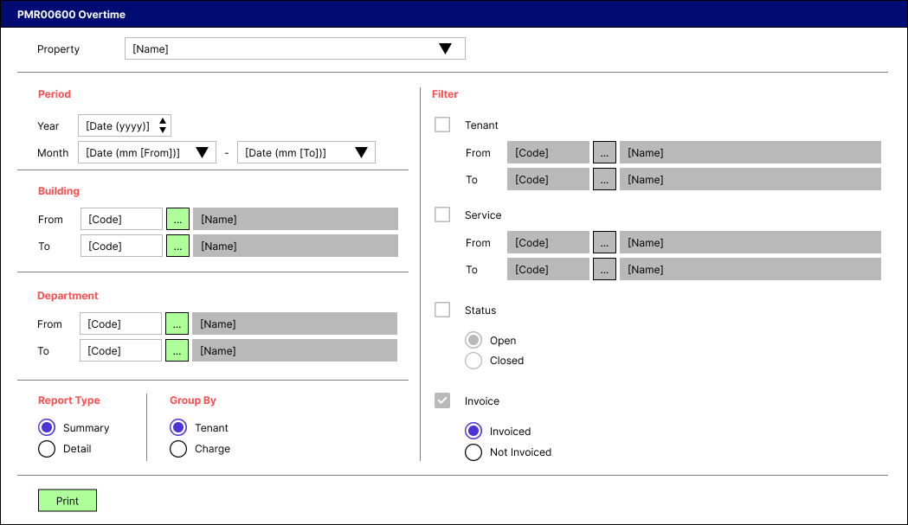

### BUTTON DEFINITION

|  |  |
| --- | --- |
| **Button Name** | **Action** |
| Print | Run PRINT REPORT PROCESS |

### DISPLAY PROCESS

#### FIELD DEFINITION

|  |  |  |  |
| --- | --- | --- | --- |
| **Name** | **Field** | **Type** | **Validation** |
| Property |  | Combo box  Set VAR_PROPERTY_LIST with  EXEC RSP_GS_GET_PROPERTY_LIST  VAR_COMPANY_ID  , VAR_USER_ID  Set property id = CPROPERTY_ID  Set property name = CPROPERTY_NAME  Set default selected property id = top 1 property id from VAR_PROPERTY_LIST.  Show name from the specific property id | * Mandatory * - |
| Period [Year] |  | Spinner  Spinner value:   * Minimum = VAR_YEAR_RANGE.IMIN_YEAR * Maximum = VAR_YEAR_RANGE.IMAX_YEAR   Set default spinner value:  SELECT YEAR(dbo.RFN_GET_DB_TODAY (VAR_COMPANY_ID)) | * Mandatory * - |
| Period [Month [From]] |  | Combo box  Set VAR_PERIOD_MONTH_LIST (as array of object) with VAR_MONTH_NUMBER and VAR_MONTH_NAME.  Set VAR_MONTH_NUMBER = 01, 02, … , 12  Set VAR_MONTH_NAME = January, February, … , December  Set default combo box value month name based on  SELECT MONTH(dbo.RFN_GET_DB_TODAY (VAR_COMPANY_ID)) | * Mandatory * - |
| Period [Month [To]] |  | Combo box  Set VAR_PERIOD_MONTH_LIST (as array of object) with VAR_MONTH_NUMBER and VAR_MONTH_NAME.  Set VAR_MONTH_NUMBER = 01, 02, … , 12  Set VAR_MONTH_NAME = January, February, … , December  Set default combo box value month name based on  SELECT MONTH(dbo.RFN_GET_DB_TODAY (VAR_COMPANY_ID)) | * Mandatory * - |
| Building [From [Code]] |  | Text box | * Mandatory * If user inputs manually, then check its name based on VAR_LOOKUP_BUILDING_LIST_GET_RECORD and save it to VAR_BUILDING_NAME. Finally: * If VAR_BUILDING_NAME is empty, then: * Display message “Building [INPUT Building Code] not found!”, [OK] * Set focus to Building [From [Code]] field * Else, set Building [From [Name]]’s value = VAR_BUILDING_NAME * - |
| Building [From [Lookup]] |  | Lookup | * Enter lookup program GSL02200 with parameters: VAR_COMPANY_ID, selected Property ID, VAR_USER_ID, 0. Then save the result to VAR_BUILDING_RESULT * If VAR_BUILDING_RESULT is empty, then: * Display message “Building [INPUT Building Code] not found!”, [OK] * Set focus to Building [From [Code]] field * Else if VAR_BUILDING_RESULT exists, then: * Set Building [From [Code]] = CBUILDING_ID * Set Building [From [Name]] = CBUILDING_NAME * - |
| Building [From [Name]] |  | Text box | * Disabled * - |
| Building [To [Code]] |  | Text box | * Mandatory * If user inputs manually, then check its name based on VAR_LOOKUP_BUILDING_LIST_GET_RECORD and save it to VAR_BUILDING_NAME. Finally: * If VAR_BUILDING_NAME is empty, then: * Display message “Building [INPUT Building Code] not found!”, [OK] * Set focus to Building [To [Code]] field * Else, set Building [To [Name]]’s value = VAR_BUILDING_NAME * - |
| Building [To [Lookup]] |  | Lookup | * Enter lookup program GSL02200 with parameters: VAR_COMPANY_ID, selected Property ID, VAR_USER_ID, 0. Then save the result to VAR_BUILDING_RESULT * If VAR_BUILDING_RESULT is empty, then: * Display message “Building [INPUT Building Code] not found!”, [OK] * Set focus to Building [To [Code]] field * Else if VAR_BUILDING_RESULT exists, then: * Set Building [To [Code]] = CBUILDING_ID * Set Building [To [Name]] = CBUILDING_NAME * - |
| Building [To [Name]] |  | Text box | * Disabled * - |
| Department [From [Code]] |  | Text box | * Mandatory * If user inputs manually, then check its name based on VAR_LOOKUP_DEPARTMENT_LIST_GET_RECORD and save it to VAR_DEPARTMENT_NAME. Finally: * If VAR_DEPARTMENT_NAME is empty, then: * Display message “Department [INPUT Department Code] not found!”, [OK] * Set focus to Department [From [Code]] field * Else, set Department [From [Name]]’s value = VAR_DEPARTMENT_NAME * - |
| Department [From [Lookup]] |  | Lookup | * Enter lookup program GSL00700 with parameters: VAR_COMPANY_ID, VAR_USER_ID. Then save the result to VAR_DEPARTMENT_RESULT * If VAR_DEPARTMENT_RESULT is empty, then: * Display message “Department [INPUT Department Code] not found!”, [OK] * Set focus to Department [From [Code]] field * Else if VAR_DEPARTMENT_RESULT exists, then: * Set Department [From [Code]] = CDEPT_CODE * Set Department [From [Name]] = CDEPT_NAME * - |
| Department [From [Name]] |  | Text box | * Disabled * - |
| Department [To [Code]] |  | Text box | * Mandatory * If user inputs manually, then check its name based on VAR_LOOKUP_DEPARTMENT_LIST_GET_RECORD and save it to VAR_DEPARTMENT_NAME. Finally: * If VAR_DEPARTMENT_NAME is empty, then: * Display message “Department [INPUT Department Code] not found!”, [OK] * Set focus to Department [To [Code]] field * Else, set Department [To [Name]]’s value = VAR_DEPARTMENT_NAME * - |
| Department [To [Lookup]] |  | Lookup | * Enter lookup program GSL00700 with parameters: VAR_COMPANY_ID, VAR_USER_ID. Then save the result to VAR_DEPARTMENT_RESULT * If VAR_DEPARTMENT_RESULT is empty, then: * Display message “Department [INPUT Department Code] not found!”, [OK] * Set focus to Department [To [Code]] field * Else if VAR_DEPARTMENT_RESULT exists, then: * Set Department [To [Code]] = CDEPT_CODE * Set Department [To [Name]] = CDEPT_NAME * - |
| Department [To [Name]] |  | Text box | * Disabled * - |
| Report Type |  | Radio button  Radio Value   * ‘1’ = Summary * ‘2’ = Detail   Set default value to Summary | * Mandatory * If selected value = Summary, then: * Disable Period [Month [From]] * Set Period [Month [From]]’s value = January * Disable Period [Month [To]] * Set Period [Month [To]]’s value = December * Set Group By’s value = Tenant * Disable Filter [Tenant] * Set Filter [Tenant]’s value = False * Disable Filter [Service] * Set Filter [Service]’s value = False * Disable Filter [Status] * Set Filter [Status]’s value = False * Disable Filter [Invoice] * Set Filter [Invoice]’s value = True * Else: * Enable Period [Month [From]] * Enable Period [Month [To]] * Enable Filter [Tenant] * Enable Filter [Service] * Enable Filter [Status] * Enable Filter [Invoice] * Set Filter [Invoice]’s value = False * - |
| Group By |  | Radio button  Radio Value   * ‘1’ = Tenant * ‘2’ = Charge   Set default value to Tenant | * Mandatory * - |
| Filter [Tenant] |  | Check box  Set:   * When True, then 1 * When False, then 0   Set default value to False | * Optional * If selected value = True, then enable: * Enable Filter [Tenant [From [Code]]] * Enable Filter [Tenant [From [Lookup]]] * Enable Filter [Tenant [To [Code]]] * Enable Filter [Tenant [To [Lookup]]] * Else if selected value = False, then disable: * Disable Filter [Tenant [From [Code]]] * Set Filter [Tenant [From [Code]]]’s value to empty * Disable Filter [Tenant [From [Lookup]]] * Disable Filter [Tenant [To [Code]]] * Set Filter [Tenant [To [Code]]]’s value to empty * Disable Filter [Tenant [To [Lookup]]] * - |
| Filter [Tenant [From [Code]]] |  | Text box | * Mandatory, if Filter [Tenant]’s value = True * If user inputs manually, then check its name based on VAR_LOOKUP_TENANT_LIST_GET_RECORD and save it to VAR_TENANT_NAME. Finally: * If VAR_TENANT_NAME is empty, then: * Display message “Tenant [INPUT Tenant Code] not found!”, [OK] * Set focus to Filter [Tenant [From [Code]]] field * Else, set Filter [Tenant [From [Name]]]’s value = VAR_TENANT_NAME * - |
| Filter [Tenant [From [Lookup]]] |  | Lookup | * Enter lookup program PML00600 with parameters: VAR_COMPANY_ID, selected Property ID, “01”, VAR_USER_ID. Then save the result to VAR_TENANT_RESULT * If VAR_TENANT_RESULT is empty, then: * Display message “Tenant [INPUT Tenant Code] not found!”, [OK] * Set focus to Filter [Tenant [From [Code]]] field * Else if VAR_TENANT_RESULT exists, then: * Set Filter [Tenant [From [Code]]] = CTENANT_ID * Set Filter [Tenant [From [Name]]] = CTENANT_NAME * - |
| Filter [Tenant [From [Name]]] |  | Text box | * Disabled * - |
| Filter [Tenant [To [Code]]] |  | Text box | * Mandatory, if Filter [Tenant]’s value = True * If user inputs manually, then check its name based on VAR_LOOKUP_TENANT_LIST_GET_RECORD and save it to VAR_TENANT_NAME. Finally: * If VAR_TENANT_NAME is empty, then: * Display message “Tenant [INPUT Tenant Code] not found!”, [OK] * Set focus to Filter [Tenant [To [Code]]] field * Else, set Filter [Tenant [To [Name]]]’s value = VAR_TENANT_NAME * - |
| Filter [Tenant [To [Lookup]]] |  | Lookup | * Enter lookup program PML00600 with parameters: VAR_COMPANY_ID, selected Property ID, “01”, VAR_USER_ID. Then save the result to VAR_TENANT_RESULT * If VAR_TENANT_RESULT is empty, then: * Display message “Tenant [INPUT Tenant Code] not found!”, [OK] * Set focus to Filter [Tenant [To [Code]]] field * Else if VAR_TENANT_RESULT exists, then: * Set Filter [Tenant [To [Code]]] = CTENANT_ID * Set Filter [Tenant [To [Name]]] = CTENANT_NAME * - |
| Filter [Tenant [To [Name]]] |  | Text box | * Disabled * - |
| Filter [Service] |  | Check box  Set:   * When True, then 1 * When False, then 0   Set default value to False | * Optional * If selected value = True, then enable: * Enable Filter [Service [From [Code]]] * Enable Filter [Service [From [Lookup]]] * Enable Filter [Service [To [Code]]] * Enable Filter [Service [To [Lookup]]] * Else if selected value = False, then disable: * Disable Filter [Service [From [Code]]] * Set Filter [Service [From [Code]]]’s value to empty * Disable Filter [Service [From [Lookup]]] * Disable Filter [Service [To [Code]]] * Set Filter [Service [To [Code]]]’s value to empty * Disable Filter [Service [To [Lookup]]] * - |
| Filter [Service [From [Code]]] |  | Text box | * Mandatory, if Filter [Service]’s value = True * If user inputs manually, then check its name based on VAR_LOOKUP_SERVICE_LIST_GET_RECORD and save it to VAR_SERVICE_NAME. Finally: * If VAR_SERVICE_NAME is empty, then: * Display message “Service [INPUT Service Code] not found!”, [OK] * Set focus to Filter [Service [From [Code]]] field * Else, set Filter [Service [From [Name]]]’s value = VAR_SERVICE_NAME * - |
| Filter [Service [From [Lookup]]] |  | Lookup | * Enter lookup program PML00400 with parameters: VAR_COMPANY_ID, selected Property ID, “08”, VAR_USER_ID. Then save the result to VAR_SERVICE_RESULT * If VAR_SERVICE_RESULT is empty, then: * Display message “Service [INPUT Service Code] not found!”, [OK] * Set focus to Filter [Service [From [Code]]] field * Else if VAR_SERVICE_RESULT exists, then: * Set Filter [Service [From [Code]]] = CCHARGES_ID * Set Filter [Service [From [Name]]] = CCHARGES_NAME * - |
| Filter [Service [From [Name]]] |  | Text box | * Disabled * - |
| Filter [Service [To [Code]]] |  | Text box | * Mandatory, if Filter [Service]’s value = True * If user inputs manually, then check its name based on VAR_LOOKUP_SERVICE_LIST_GET_RECORD and save it to VAR_SERVICE_NAME. Finally: * If VAR_SERVICE_NAME is empty, then: * Display message “Service [INPUT Service Code] not found!”, [OK] * Set focus to Filter [Service [To [Code]]] field * Else, set Filter [Service [To [Name]]]’s value = VAR_SERVICE_NAME * - |
| Filter [Service [To [Lookup]]] |  | Lookup | * Enter lookup program PML00400 with parameters: VAR_COMPANY_ID, selected Property ID, “08”, VAR_USER_ID. Then save the result to VAR_SERVICE_RESULT * If VAR_SERVICE_RESULT is empty, then: * Display message “Service [INPUT Service Code] not found!”, [OK] * Set focus to Filter [Service [To [Code]]] field * Else if VAR_SERVICE_RESULT exists, then: * Set Filter [Service [To [Code]]] = CCHARGES_ID * Set Filter [Service [To [Name]]] = CCHARGES_NAME * - |
| Filter [Service [To [Name]]] |  | Text box | * Disabled * - |
| Filter [Status] |  | Check box  Set:   * When True, then 1 * When False, then 0   Set default value to False | * Optional * If selected value = True, then enable: * Enable Filter [Status [Sub]] * Else if selected value = False, then disable: * Disable Filter [Status [Sub]] * - |
| Filter [Status [Sub]] |  | Radio button  Radio Value   * ‘1’ = Open * ‘2’ = Closed   Set default value to Open | * Mandatory, if Filter [Status]’s value = True * - |
| Filter [Invoice] |  | Check box  Set:   * When True, then 1 * When False, then 0   Set default value to False | * Optional * If selected value = True, then enable: * Enable Filter [Invoice [Sub]] * Else if selected value = False, then disable: * Disable Filter [Invoice [Sub]] * - |
| Filter [Invoice [Sub]] |  | Radio button  Radio Value   * ‘1’ = Invoiced * ‘2’ = Not Invoiced   Set default value to Invoiced | * Mandatory, if Filter [Invoice]’s value = True * - |

### PRINT REPORT PROCESS

#### REPORT LAYOUT

REPORT TYPE: SUMMARY && GROUP BY: TENANT

PAPER SIZE: A4 PORTRAIT

FONT SIZE: 7

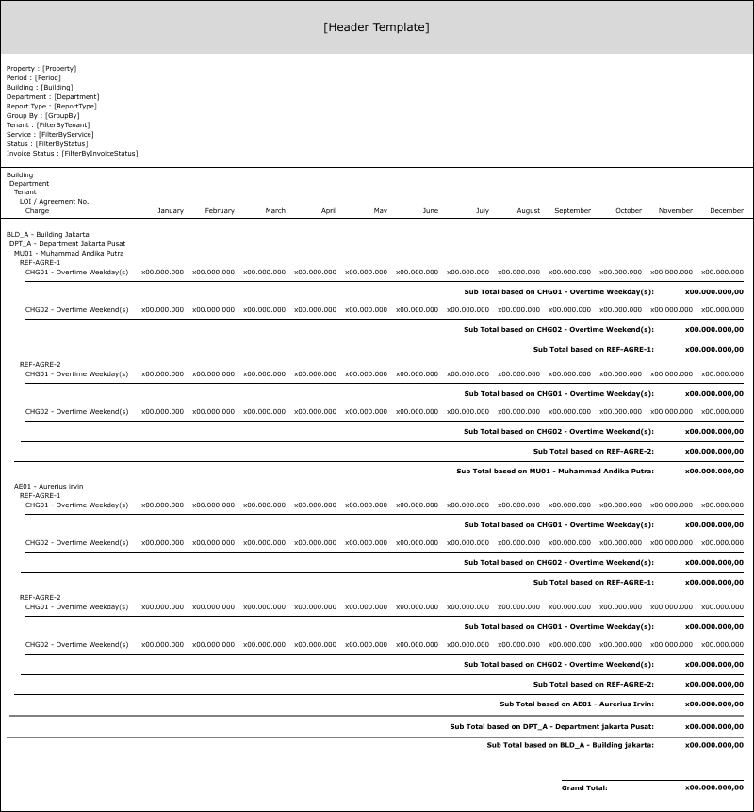

REPORT TYPE: SUMMARY && GROUP BY: CHARGE

PAPER SIZE: A4 PORTRAIT

FONT SIZE: 7

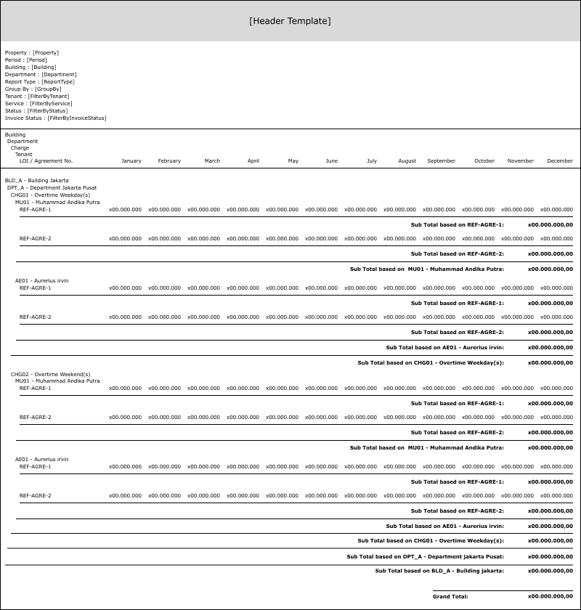

REPORT TYPE: DETAIL && GROUP BY: TENANT

PAPER SIZE: A4 PORTRAIT

FONT SIZE: 7

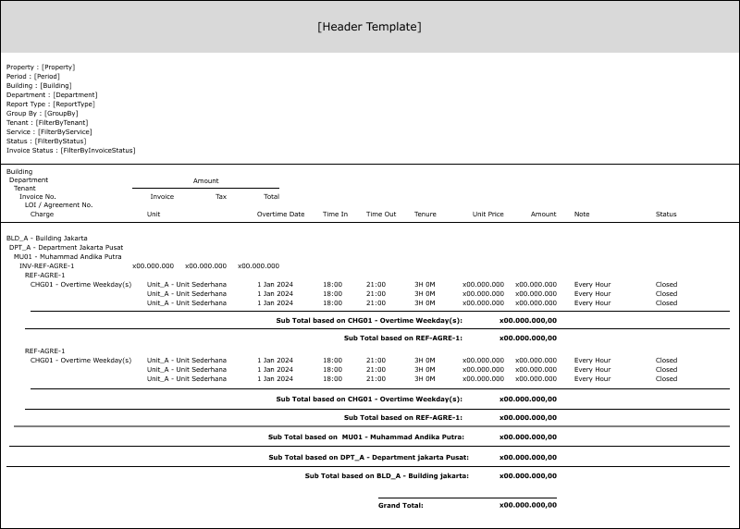

REPORT TYPE: DETAIL && GROUP BY: CHARGE

PAPER SIZE: A4 PORTRAIT

FONT SIZE: 7

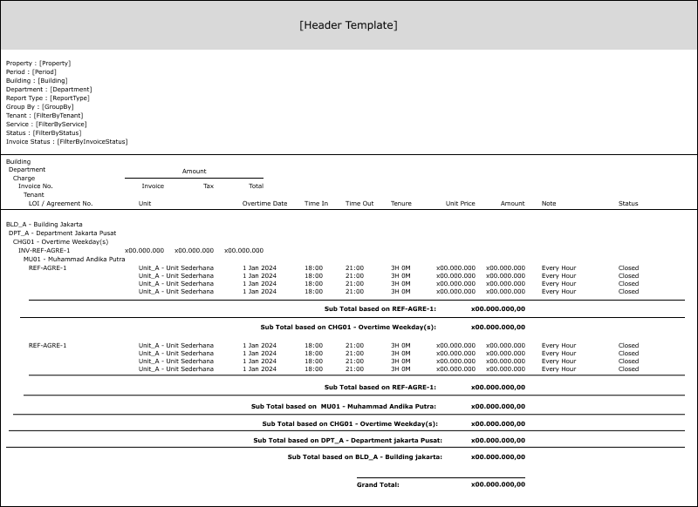

#### REPORT DEFINITION

REPORT HEADER (for all reports)

|  |  |  |  |
| --- | --- | --- | --- |
| **Section** | **Name** | **Field** | **Validation** |
| HEADER 1 | Property | Selected Property | Show Property ID – Property Name  Ex. “ABCDE – Global Property” |
| Period | Selected Period (From & To) | Show Period [Year] and Period [Month]  Ex. “September 2001” |
| Building | Selected Building (From & To) | IF Building [From [Code]] <> Building [To [Code]], then “Building [From [Name]] (Building [From [Code]]) - Building [To [Name]] (Building [To [Code]])”  ELSE, “Building [From [Name]] (Building [From [Code]])”  Ex. 1  Selected from: yyy – Building Y  Selected to: zzz – Building Z  Hence, show “Building Y (yyy) – Building Z (zzz)”  Ex. 2  Selected from: yyy – Building Y  Selected to: yyy – Building Y  Hence, show “Building Y (yyy)” |
| Department | Selected Department (From & To) | IF Department [From [Code]] <> Department [To [Code]], then “Department [From [Name]] (Department [From [Code]]) - Department [To [Name]] (Department [To [Code]])”  ELSE, “Department [From [Name]] (Department [From [Code]])”  Ex. 1  Selected from: yyy – Department Y  Selected to: zzz – Department Z  Hence, show “Department Y (yyy) – Department Z (zzz)”  Ex. 2  Selected from: yyy – Department Y  Selected to: yyy – Department Y  Hence, show “Department Y (yyy)” |
| Report Type | Selected Report Type | Show Report Type’s value  Ex. “Summary” |
| Group By | Selected Group By | Show Group By’s value  Ex. “Tenant” |
| Header 2 | Filter By Tenant | Selected Tenant (From & To) | If Filter [Tenant] = False, then suppress this section |
| Header 3 | Filter By Service | Selected Service (From & To) | If Filter [Service] = False, then suppress this section  Else,  Show “Filter by Service:” concatenated with Filter [Service [From [Code]]], Filter [Service [From [Name]]], [Service [To [Code]]], & [Service [To [Name]]]  IF Filter [Service [From [Code]]] <> [Service [To [Code]]], then “[Filter [Service [From [Name]]]] ([Filter [Service [From [Code]]]]) - [Filter [Service [To [Name]]]] ([Filter [Service [To [Code]]]])”  ELSE, “[Filter [Service [From [Name]]]] ([Filter [Service [From [Code]]]])”  Ex. 1  Selected from: yyy – Service Y  Selected to: zzz – Service Z  Hence, “Filter by Service: Service Y (yyy) – Service Z (zzz)”  Ex. 2  Selected from: yyy – Service Y  Selected to: yyy – Service Y  Hence, “Filter by Service: Service Y (yyy)” |
| Header 4 | Filter By Status | Selected Status | If Filter [Status] = False, then suppress this section  ELSE, Show “Filter by Status:” concatenated with Filter [Status [Sub]]  Ex.  Selected status: “Open”  Hence, “Filter by Status: Open” |
| Header 5 | Filter By Invoice Status | Selected Invoice | If Filter [Invoice] = False, then suppress this section  ELSE, Show “Filter by Invoice Status:” concatenated with Filter [Invoice [Sub]]  Ex.  Selected status: “Not Invoiced”  Hence, “Filter by Invoice: Not Invoiced” |

REPORT TYPE: SUMMARY && GROUP BY: TENANT

|  |  |  |  |
| --- | --- | --- | --- |
| **Report** | **Name** | **Field** | **Validation** |
| REPORT GROUP | Building | CBUILDING_ID |  |
| Department | CDEPT_CODE |  |
| Tenant | CTENANT_ID |  |
| LOI / Agreement No. | CAGREEMENT_NO |  |
| GROUP BY BUILDING [HEADER] | Building | CBUILDING_ID - CBUILDING_NAME |  |
| GROUP BY DEPARTMENT [HEADER] | Department | CDEPT_CODE - CDEPT_NAME |  |
| GROUP BY TENANT [HEADER] | Tenant | CTENANT_ID - CTENANT_NAME |  |
| GROUP BY LOI / AGREEMENT NO. [HEADER] | LOI / Agreement No. | CAGREEMENT_NO |  |
| DETAIL 1 | Charge | CCHARGE_ID - CCHARGE_NAME |  |
| January | NJAN_AMOUNT |  |
| February | NFEB_AMOUNT |  |
| March | NMAR_AMOUNT |  |
| April | NAPR_AMOUNT |  |
| May | NMAY_AMOUNT |  |
| June | NJUN_AMOUNT |  |
| July | NJUL_AMOUNT |  |
| August | NAUG_AMOUNT |  |
| September | NSEP_AMOUNT |  |
| October | NOCT_AMOUNT |  |
| November | NNOV_AMOUNT |  |
| December | NDEC_AMOUNT |  |
| DETAIL 2 | Sub Total |  | Formula:  NJAN_AMOUNT  + NFEB_AMOUNT  + NMAR_AMOUNT  + NAPR_AMOUNT  + NMAY_AMOUNT  + NJUN_AMOUNT  + NJUL_AMOUNT  + NAUG_AMOUNT  + NSEP_AMOUNT  + NOCT_AMOUNT  + NNOV_AMOUNT  + NDEC_AMOUNT |
| GROUP BY LOI / AGREEMENT NO. [FOOTER] | Sub Total |  | Sum of DETAIL 2 [Sub Total] |
| GROUP BY TENANT [FOOTER] | Sub Total |  | Sum of GROUP BY LOI / AGREEMENT NO. [Footer] [Sub Total] |
| GROUP BY DEPARTMENT [FOOTER] | Sub Total |  | Sum of GROUP BY TENANT [Footer] [Sub Total] |
| GROUP BY BUILDING [FOOTER] | Sub Total |  | Sum of GROUP BY DEPARTMENT [Footer] [Sub Total] |
| REPORT FOOTER | Grand Total |  | Sum of GROUP BY BUILDING [Footer] [Sub Total] |

REPORT TYPE: SUMMARY && GROUP BY: CHARGE

|  |  |  |  |
| --- | --- | --- | --- |
| **Report** | **Name** | **Field** | **Validation** |
| REPORT GROUP | Building | CBUILDING_ID |  |
| Department | CDEPT_CODE |  |
| Charge | CCHARGE_ID |  |
| Tenant | CTENANT_ID |  |
| GROUP BY BUILDING [HEADER] |  | CBUILDING_ID - CBUILDING_NAME |  |
| GROUP BY DEPARTMENT [HEADER] |  | CDEPT_CODE - CDEPT_NAME |  |
| GROUP BY CHARGE [HEADER] |  | CCHARGE_ID - CCHARGE_NAME |  |
| GROUP BY TENANT [HEADER] |  | CTENANT_ID - CTENANT_NAME |  |
| DETAIL 1 | LOI / Agreement No. | CAGREEMENT_NO |  |
| DETAIL 2 | Sub Total |  | Formula:  NJAN_AMOUNT  + NFEB_AMOUNT  + NMAR_AMOUNT  + NAPR_AMOUNT  + NMAY_AMOUNT  + NJUN_AMOUNT  + NJUL_AMOUNT  + NAUG_AMOUNT  + NSEP_AMOUNT  + NOCT_AMOUNT  + NNOV_AMOUNT  + NDEC_AMOUNT |
| GROUP BY TENANT [FOOTER] | Sub Total |  | Sum of DETAIL 2 [Sub Total] |
| GROUP BY CHARGE [FOOTER] | Sub Total |  | Sum of GROUP BY TENANT [Footer] [Sub Total] |
| GROUP BY DEPARTMENT [FOOTER] | Sub Total |  | Sum of GROUP BY CHARGE [Footer] [Sub Total] |
| GROUP BY BUILDING [FOOTER] | Sub Total |  | Sum of GROUP BY DEPARTMENT [Footer] [Sub Total] |
| REPORT FOOTER | Grand Total |  | Sum of GROUP BY BUILDING [Footer] [Sub Total] |

REPORT TYPE: DETAIL && GROUP BY: TENANT

|  |  |  |  |
| --- | --- | --- | --- |
| **Report** | **Name** | **Field** | **Validation** |
| REPORT GROUP | Building | CBUILDING_ID |  |
| Department | CDEPT_CODE |  |
| Tenant | CTENANT_ID |  |
| Invoice No. | CINVOICE_NO |  |
| LOI / Agreement No. | CAGREEMENT_NO |  |
| Charge | CCHARGE_ID |  |
| GROUP BY BUILDING [HEADER] | Building | CBUILDING_ID - CBUILDING_NAME |  |
| GROUP BY DEPARTMENT [HEADER] | Department | CDEPT_CODE - CDEPT_NAME |  |
| GROUP BY TENANT [HEADER] | Tenant | CTENANT_ID - CTENANT_NAME |  |
| GROUP BY INVOICE NO. [HEADER] | Invoice No. | CINVOICE_NO |  |
| Invoice Amount | NINVOICE_AMOUNT |  |
| Tax Amount | NINVOICE_TAX_AMOUNT |  |
| Total Amount | NINVOICE_TOTAL_AMOUNT |  |
| GROUP BY LOI / AGREEMENT NO. [HEADER] | LOI / Agreement No. | CAGREEMENT_NO |  |
| GROUP BY CHARGE [HEADER] | Charge | CCHARGE_ID - CCHARGE_NAME |  |
| DETAIL 1 | Unit | CUNIT_ID - CUNIT_NAME |  |
|  | Overtime Date | COVERTIME_DATE |  |
|  | Time In | CTIME_IN |  |
|  | Time Out | CTIME_OUT |  |
|  | Tenure | CTENURE |  |
|  | Unit Price | NUNIT_PRICE |  |
|  | Amount | NUNIT_ACTUAL_AMOUNT |  |
|  | Note | CNOTE |  |
|  | Status | CTRANS_STATUS_NAME |  |
| GROUP BY CHARGE [FOOTER] | Sub Total |  | Sum of NUNIT_ACTUAL_AMOUNT |
| GROUP BY LOI / AGREEMENT NO. [FOOTER] | Sub Total |  | Sum of NUNIT_ACTUAL_AMOUNT |
| GROUP BY TENANT [FOOTER] | Sub Total |  | Sum of NUNIT_ACTUAL_AMOUNT |
| GROUP BY DEPARTMENT [FOOTER] | Sub Total |  | Sum of NUNIT_ACTUAL_AMOUNT |
| GROUP BY BUILDING [FOOTER] | Sub Total |  | Sum of NUNIT_ACTUAL_AMOUNT |
| REPORT FOOTER | Grand Total |  | Sum of NUNIT_ACTUAL_AMOUNT |

REPORT TYPE: DETAIL && GROUP BY: CHARGE

|  |  |  |  |
| --- | --- | --- | --- |
| **Report** | **Name** | **Field** | **Validation** |
| REPORT GROUP | Building | CBUILDING_ID |  |
| Department | CDEPT_CODE |  |
| Charge | CCHARGE_ID |  |
| Invoice No. | CINVOICE_NO |  |
| Tenant | CTENANT_ID |  |
| LOI / Agreement No. | CAGREEMENT_NO |  |
| GROUP BY BUILDING [HEADER] | Building | CBUILDING_ID - CBUILDING_NAME |  |
| GROUP BY DEPARTMENT [HEADER] | Department | CDEPT_CODE - CDEPT_NAME |  |
| GROUP BY CHARGE [HEADER] | Charge | CCHARGE_ID - CCHARGE_NAME |  |
| GROUP BY INVOICE NO. [HEADER] | Invoice No. | CINVOICE_NO |  |
| Invoice Amount | NINVOICE_AMOUNT |  |
| Tax Amount | NINVOICE_TAX_AMOUNT |  |
| Total Amount | NINVOICE_TOTAL_AMOUNT |  |
| GROUP BY TENANT [HEADER] | Tenant | CTENANT_ID - CTENANT_NAME |  |
| GROUP BY LOI / AGREEMENT NO. [HEADER] | LOI / Agreement No. | CAGREEMENT_NO |  |
| DETAIL 1 | Unit | CUNIT_ID - CUNIT_NAME |  |
| Overtime Date | COVERTIME_DATE |  |
| Time In | CTIME_IN |  |
| Time Out | CTIME_OUT |  |
| Tenure | CTENURE |  |
| Unit Price | NUNIT_PRICE |  |
| Amount | NUNIT_ACTUAL_AMOUNT |  |
| Note | CNOTE |  |
| Status | CTRANS_STATUS_NAME |  |
| GROUP BY LOI / AGREEMENT NO. [FOOTER] | Sub Total |  | Sum of NUNIT_ACTUAL_AMOUNT |
| GROUP BY TENANT [FOOTER] | Sub Total |  | Sum of NUNIT_ACTUAL_AMOUNT |
| GROUP BY CHARGE [FOOTER] | Sub Total |  | Sum of NUNIT_ACTUAL_AMOUNT |
| GROUP BY DEPARTMENT [FOOTER] | Sub Total |  | Sum of NUNIT_ACTUAL_AMOUNT |
| GROUP BY BUILDING [FOOTER] | Sub Total |  | Sum of NUNIT_ACTUAL_AMOUNT |
| REPORT FOOTER | Grand Total |  | Sum of NUNIT_ACTUAL_AMOUNT |

#### VALIDATION

|  |  |  |
| --- | --- | --- |
| **Field** | **Condition** | **Validation Message** |
| Property | Empty | Please select Property |
| Period | (Period [Year] or Period [From [Month]] or Period [To [Month]]) is empty | Please select Period |
| Building | (Building [From [Code]] or Building [To [Code]]) is empty | Please select Building |
| Department | (Department [From [Code]] or Department [To [Code]]) is empty | Please select Department |
| Filter [Tenant] | Filter [Tenant] = True and (Filter [Tenant [From [Code]]] or Filter [Tenant [To [Code]]]) is empty | Please select Tenant |
| Filter [Service] | Filter [Service] = True and (Filter [Service [From [Code]]] or Filter [Service [To [Code]]]) is empty | Please select Service |

#### ACTION

|  |
| --- |
|  |
| * Execute this stored procedure:   RSP_PMR00600_GET_REPORT  **VAR_COMPANY_ID**  , **selected Property ID**  , **selected Period [From]**  , **selected Period [To]**  , **selected Building [From]**  **, selected Building [To]**  **, selected Department [From]**  **, selected Department [To]**  **, selected Report Type**  , selected Tenant [From]  , selected Tenant [To]  , selected Service [From]  , selected Service [To]  , selected Status  , selected Invoice  **, VAR_LANGUAGE_ID**  Note for sending those parameters to execute the stored procedure above:   * Bolded words are **MANDATORY** parameters, the rest of it can be not filled (not null value, but empty string value) * **Different Report Type’s value resulting in different outputs** from the stored procedure above * Selected Period [From]’s value should be “yyyymm” * Selected Period [To]’s value should be “yyyymm” * Selected Status’ value should be ‘0’ or ‘1’ * Selected Invoice’s value should be either ‘0’ or ‘1’   Note for choosing which report to be executed based on its parameters:   * If **Report Type = ‘1’ AND Group By = ‘1’**, then open **REPORT TYPE: SUMMARY && GROUP BY: TENANT** report * If **Report Type = ‘1’ AND Group By = ‘2’**, then open **REPORT TYPE: SUMMARY && GROUP BY: CHARGE** report * If **Report Type = ‘2’ AND Group By = ‘1’**, then open **REPORT TYPE: DETAIL && GROUP BY: TENANT** report * If **Report Type = ‘2’ AND Group By = ‘2’**, then open **REPORT TYPE: DETAIL && GROUP BY: CHARGE** report * Ex. [THERE IS CURRENTLY NO AVAILABLE DATA // TABLE IS NOT EXISTS]   EXEC RSP_PMR00600_GET_REPORT  'RCD'  , 'JBMPC'  , '202401'  , '202412'  , ''  , ''  , ''  , ''  , '1'  , ''  , ''  , ''  , ''  , ''  , ''  , 'EN'   * - |

# CR LIST

|  |  |  |
| --- | --- | --- |
| **CR** | **Description** | **Notes** |
|  |  |  |

#### TEMPLATE

#### VALIDATION

|  |  |  |
| --- | --- | --- |
| **Field** | **Condition** | **Validation Message** |
|  |  |  |
|  |  |  |

#### ACTION

|  |
| --- |
|  |
|  |